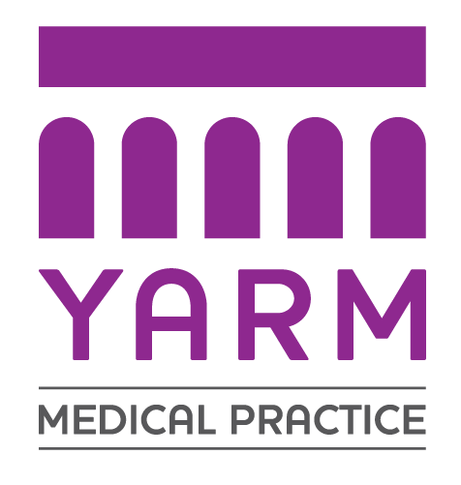
YARM MEDICAL PRACTICE NON-NHS (PRIVATE) FEES
REVIEWED 27 JUNE 2022
ALL PRICES INCLUSIVE OF VAT

SERVICE | FEE (inc VAT)
CERTIFICATES AND FORMS
Simple Letter (eg: To Whom It May Concern) | £50.00 fee which must be paid on requesting work / handing in forms.  Letters / Forms may take up to 20 working days to produce / complete.  Patient will be contacted when the Letter / Form is ready to collect from the Surgery.  We do NOT post out Letters / Forms.
Parachute/ Participation in a specific event
Cancellation / Delay of Gym Membership Letter
Certificate for Fitness to attend work / travel / exercise / fly / university
Certificate of Existence or Verification of Applicant
Claim Forms (includes simple accidents, sickness, holiday cancellations)
Firearms Licence Application – completion of Proforma
Fitness to participate in TV / Film / to attend Gym
Ofsted Report (Childminding) | £85.00
REPORTS
Report for Solicitor (ie: Power of Attorney) | Hourly rate
MEDICAL EXAMINATION AND REPORT
HGV/PSV/Tax Medical | £120.00
Pre-Employment Medical (full medical) 45 mins investigations extra | £180.00
Medical Examination and Report | £180.00
PRIVATE PATIENT FEES
Consultation at the Surgery - 20 minutes appointment | £60.00
Private Prescription / Private Sick Note | £16.50
Home Visit | £90.00
PRIVATE EXAMINATION / TESTING
Venepuncture (Phlebotomy) – (price of lab test extra - POA) | £30.00
Spirometry (Private) | £75.00
ECG | £75.00
Paternity testing(not including test kit or diagnosis) | Blood = £30.00  Swab = £15.00
GP Hourly Rate = £200.00 POA = price on application

**PAYMENT FOR ALL NON-NHS SERVICES IS
REQUIRED BEFORE WORK IS UNDERTAKEN**

