1. Beginning on the home page of the practice website: https://www.yarmmedicalpractice.nhs.uk/
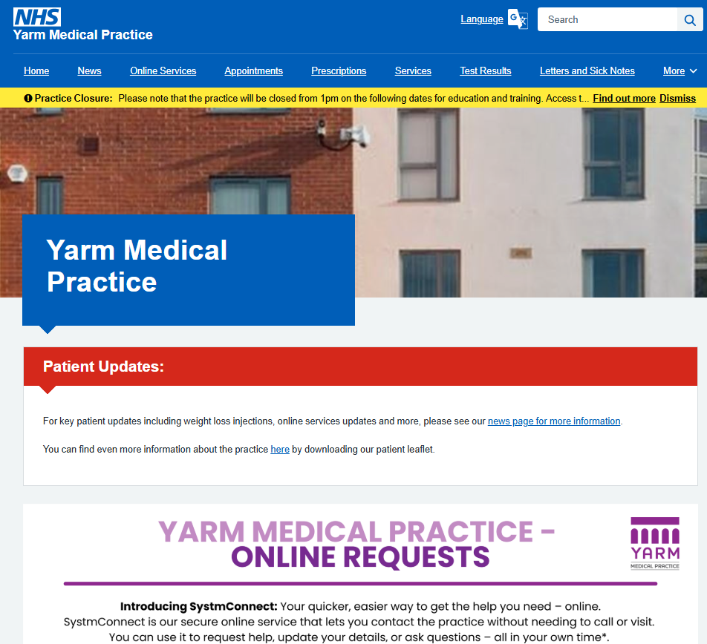
2. Scroll down until you see the SystmConnect Section:
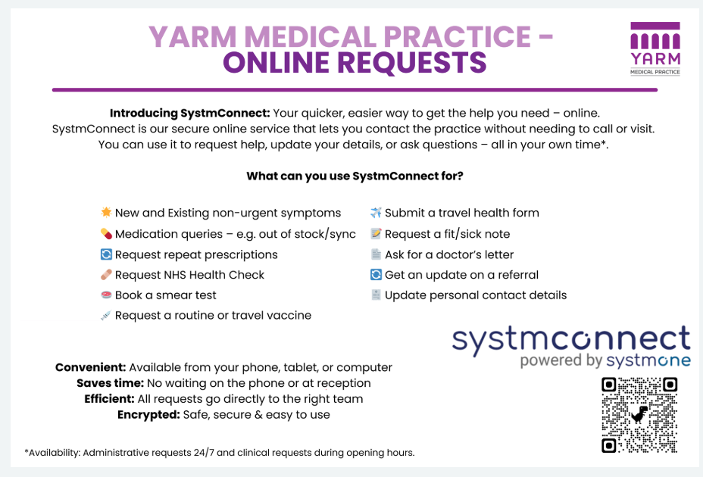
3. To find out more about SystmConnect, click the link in the text box. To submit a new request, simply click anywhere on the larger SystmConnect graphic.
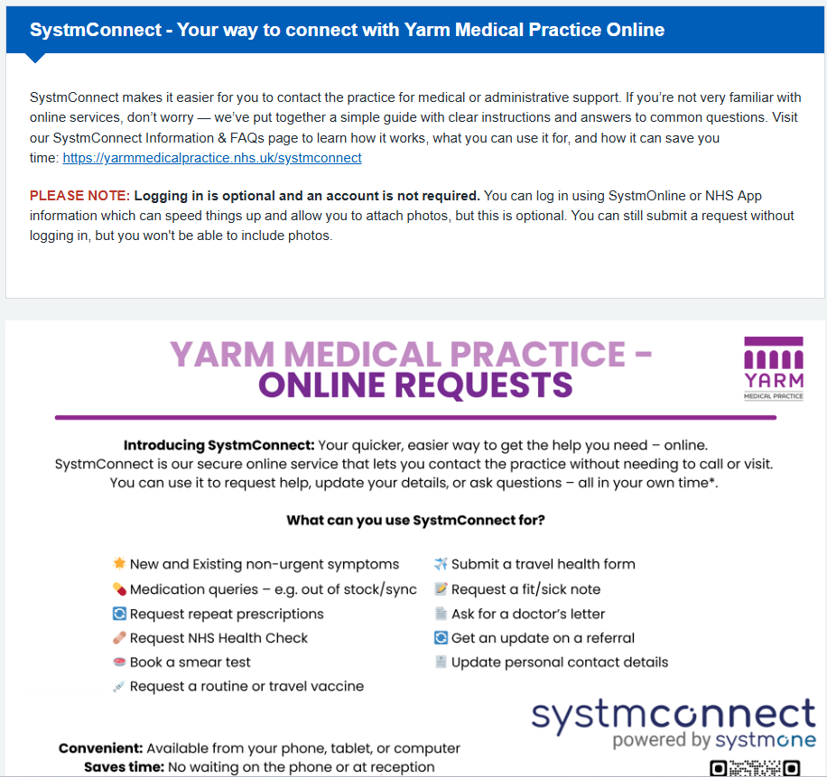
4. OPTIONAL: Log in using your SystmOnline or NHS App information. This will speed things up and mean you won’t need to enter all your information e.g. name, address etc.
a. On the next screen, you will see a range of categories. Please note that some categories include multiple options, please look at the table below for what request types are in each category:

(Available 7.30am to 6.30pm) | (Available 24/7)
Non-Urgent Medical Conditions | Health Review | Other Medical Request | Self-Referral | Doctor's Letter | Fit Note | Medication Request
New clinical problems | Anti-depressant review | Request an NHS health check | Self-Referral for Social Prescribing (not for clinical queries) | Request a letter from a GP | Request a fit note | Ask for a one-off medication again
Existing clinical problems | Combined contraception | Request a smear test |  |  |  | Order repeat medication
 | Depression review | Request a vaccine |  |  |  | Out of stock medication
 | Hormone replacement therapy | Travel form |  |  |  | Medication questions
 | Medication review | Update my profile e.g. weight, Blood Pressure |  |  |  | My medications don't line up
 | Progesterone only pill | Fit note request
b.
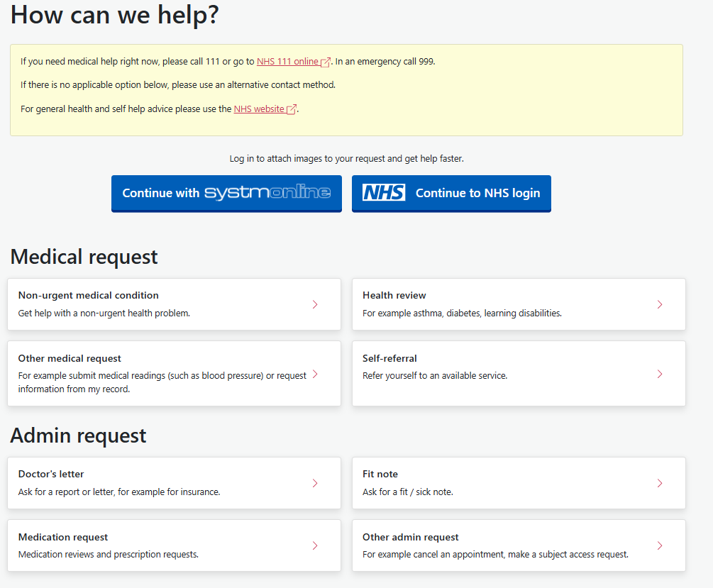
5. After clicking the category – in this case "Other admin request" you will see the types of requests within the category. Click on the type of query you wish to send. In this case, we have highlighted "Patient details update" where you might request a change of address, for example:
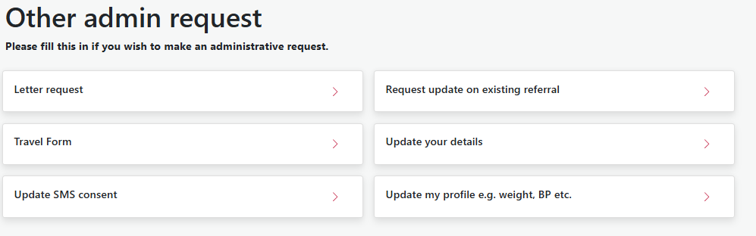
6. We need to make sure you are not trying to contact the practice for emergency reasons. Please acknowledge that you are raising a non-urgent request:
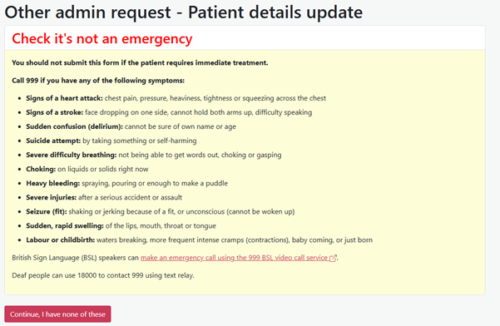
7. Complete the form with the information that the practice needs to know to handle your request correctly and efficiently:
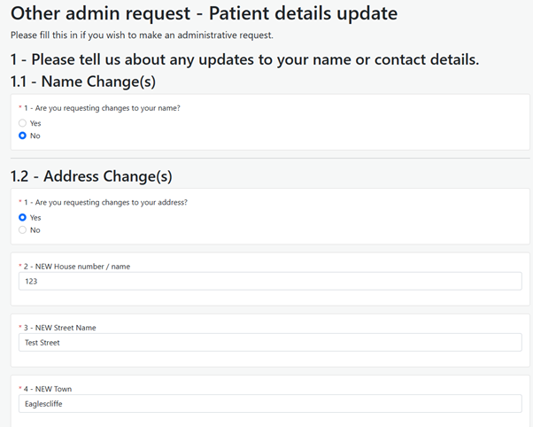
8. Once complete, click the "Next" button at the bottom of the form:
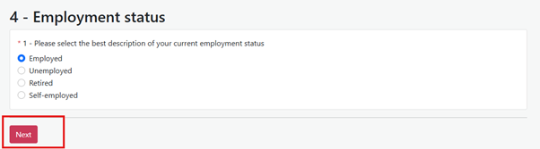
9. Fill out your information indicating whether the request is for you, someone else or if you are a healthcare professional.
a. If it is on behalf of someone else the form will ask for both your information, and the information of the person you are raising the request for:
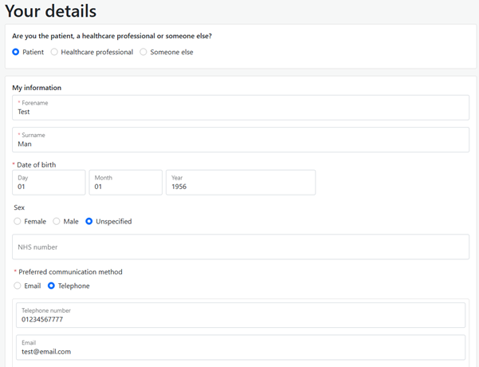
10. Once you have completed all the required fields, you can click on the submit button located at the bottom of the form:
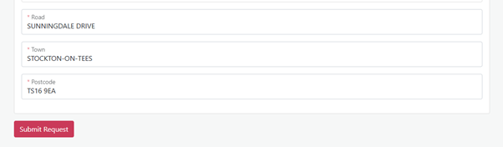
11. You will see a confirmation message advising that your request has been submitted. You don't need to take any further action, and the practice team will be in touch with the next steps. This could be via SMS/email/phone call.
a. Please note: If you need to withdraw or correct a request it is advisable for you to call the practice, instead of submitting another request as it is likely that your first request will be seen first.

